**Assessment – 1**

1 ans.

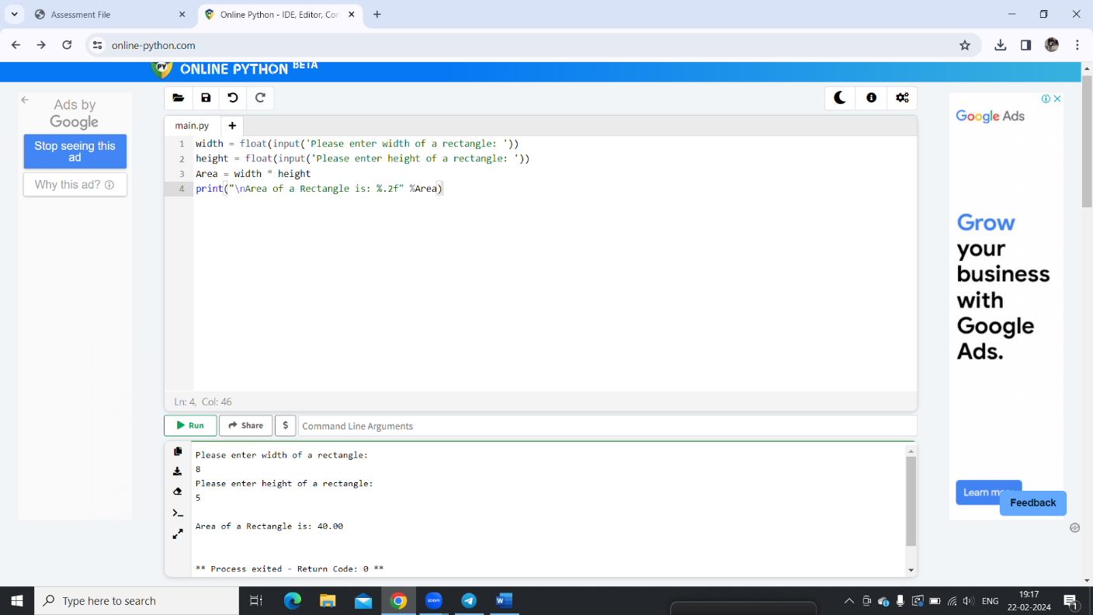

2 ans.

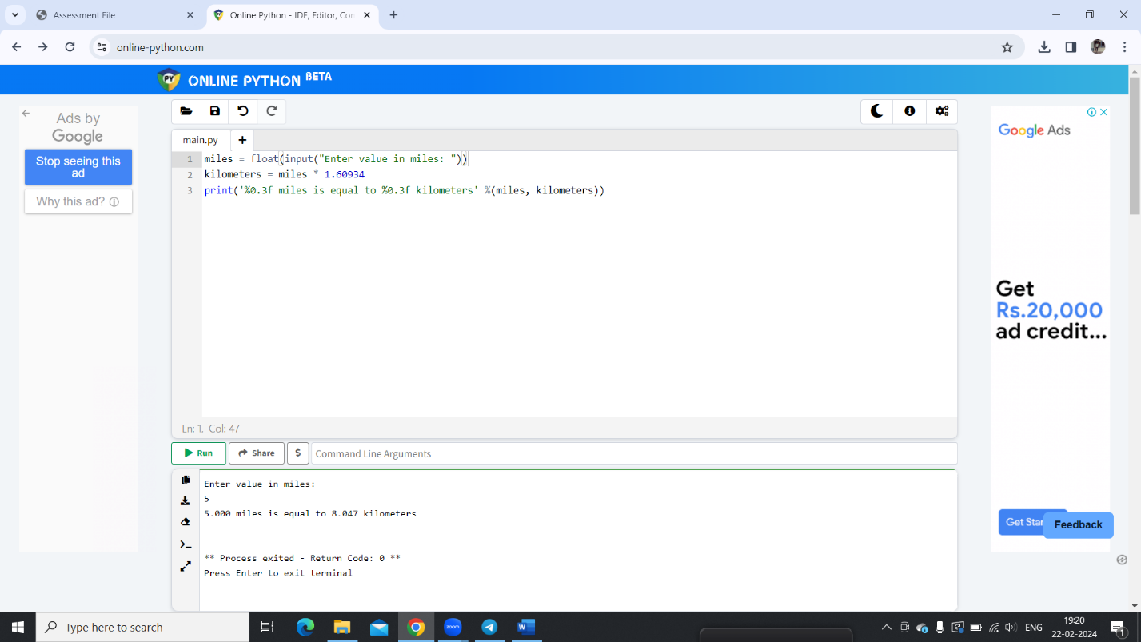

3 ans.

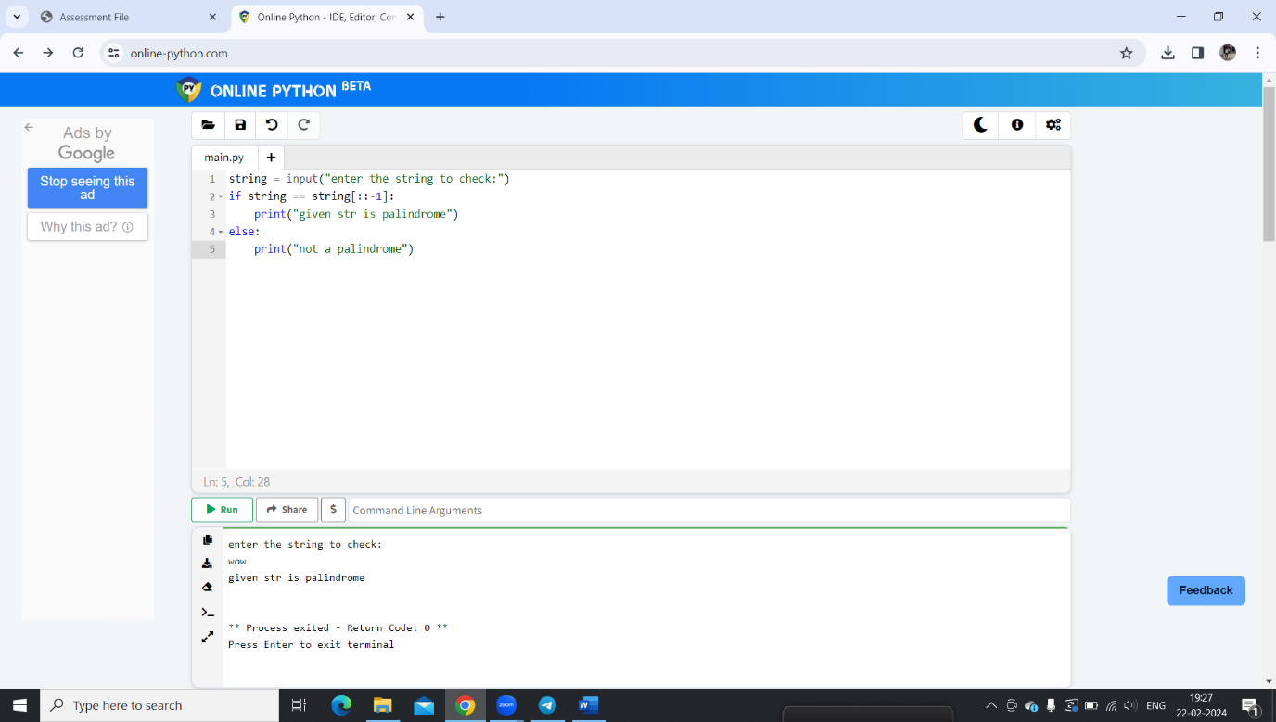

4 ans.

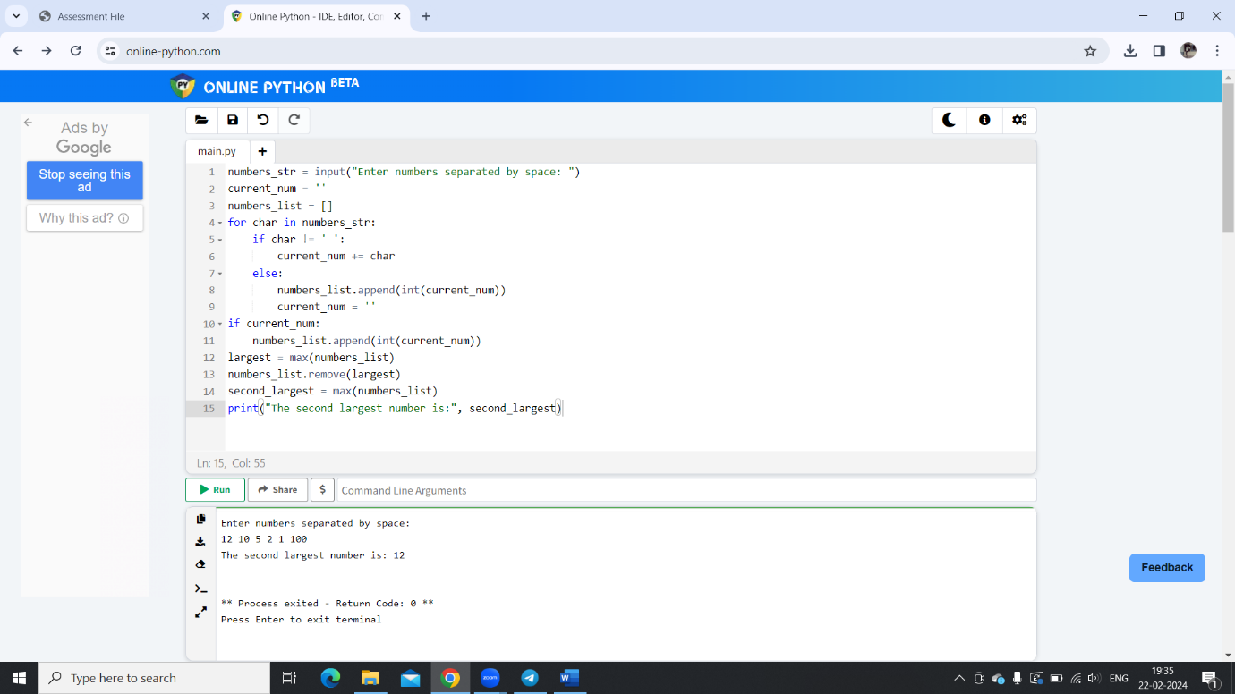

5 ans.

In Python, indentation is the spaces you put at the beginning of a line to show where blocks of code start and end. It's like the way you use paragraphs and spacing in writing to organize your thoughts. Python uses indentation to determine the structure of your code instead of using braces or keywords like other programming languages do. So, proper indentation is really important in Python to make sure your code works correctly.

6ans.

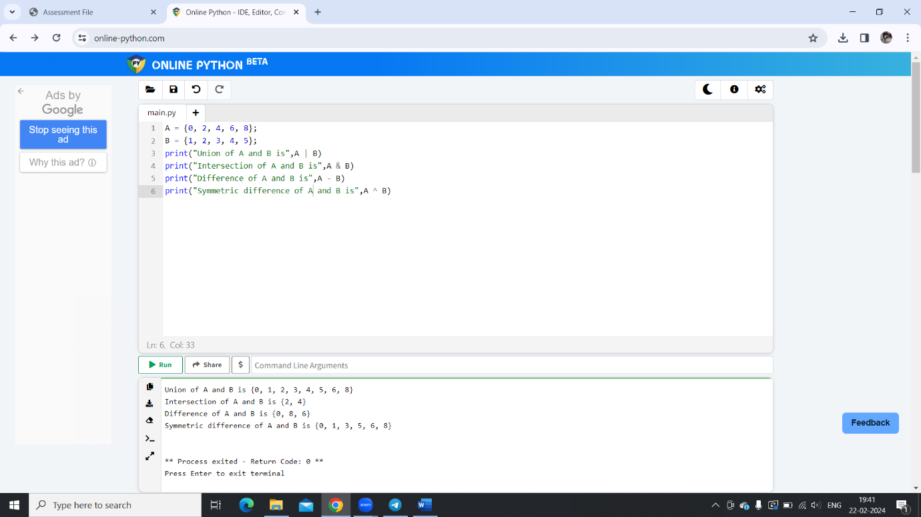

7 ans.

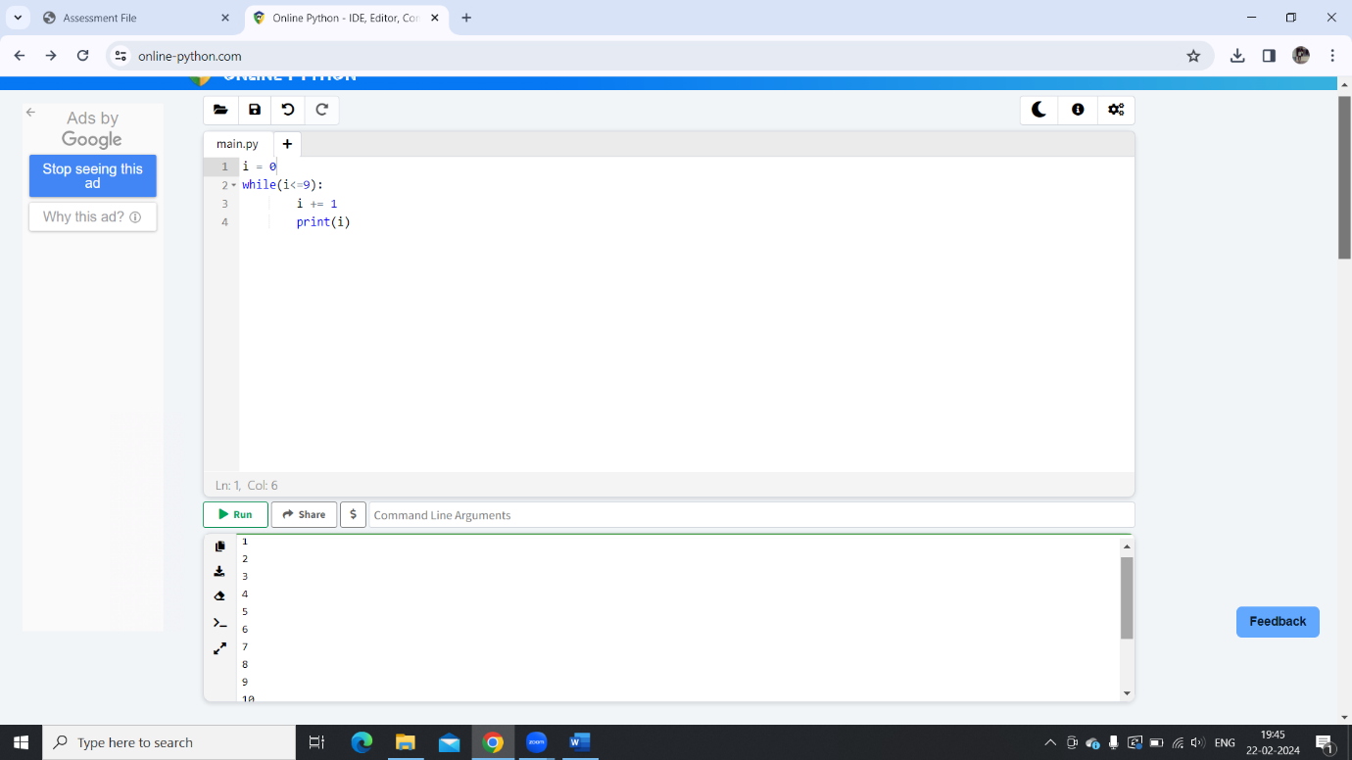

8 ans.

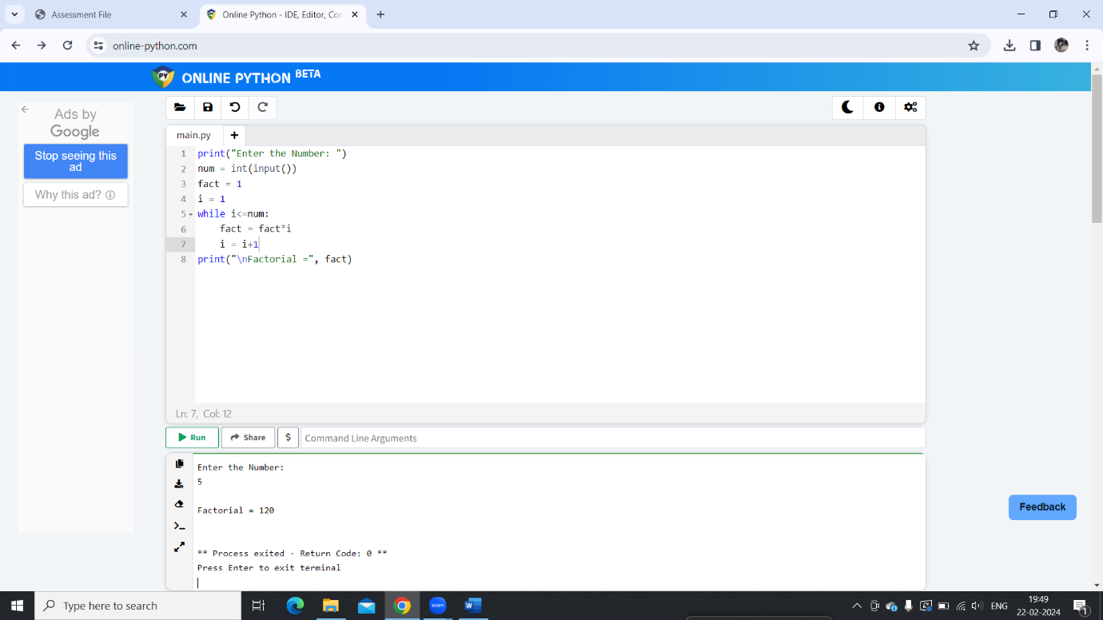

9 ans.

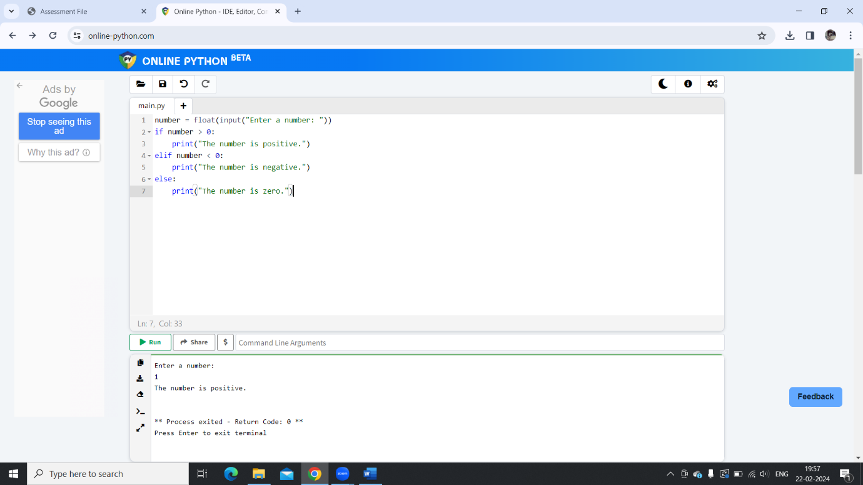

10 ans.

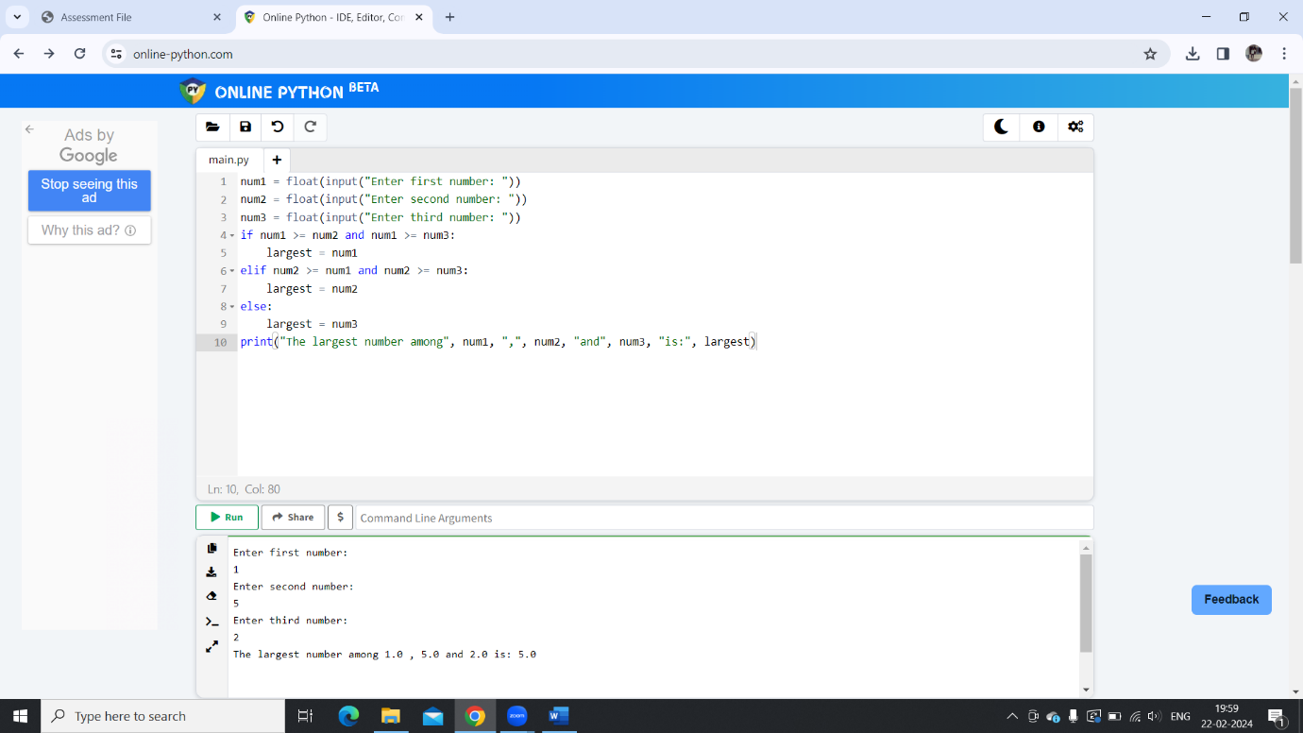

11 ans.

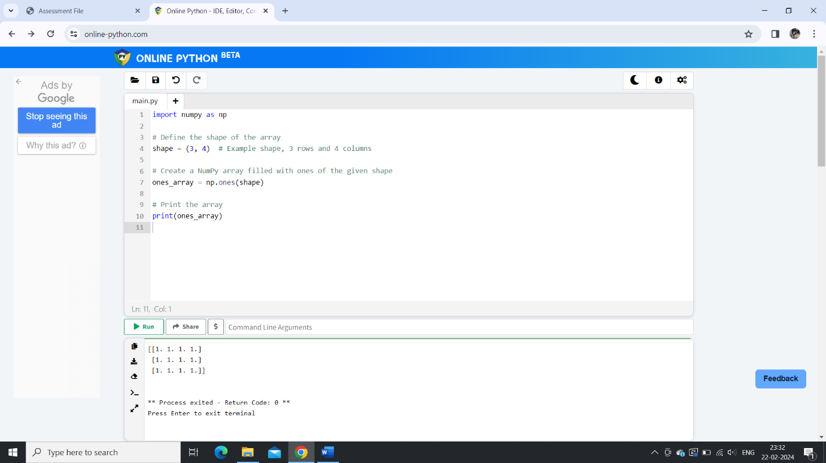12 ans.

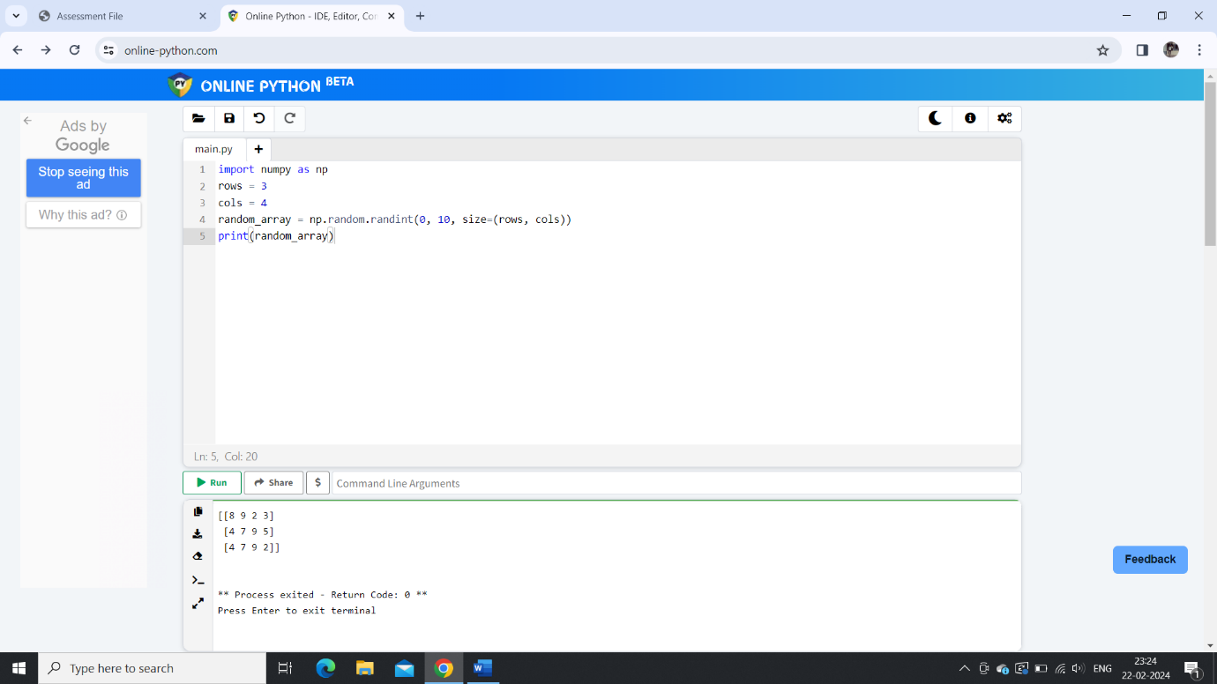

13 ans.

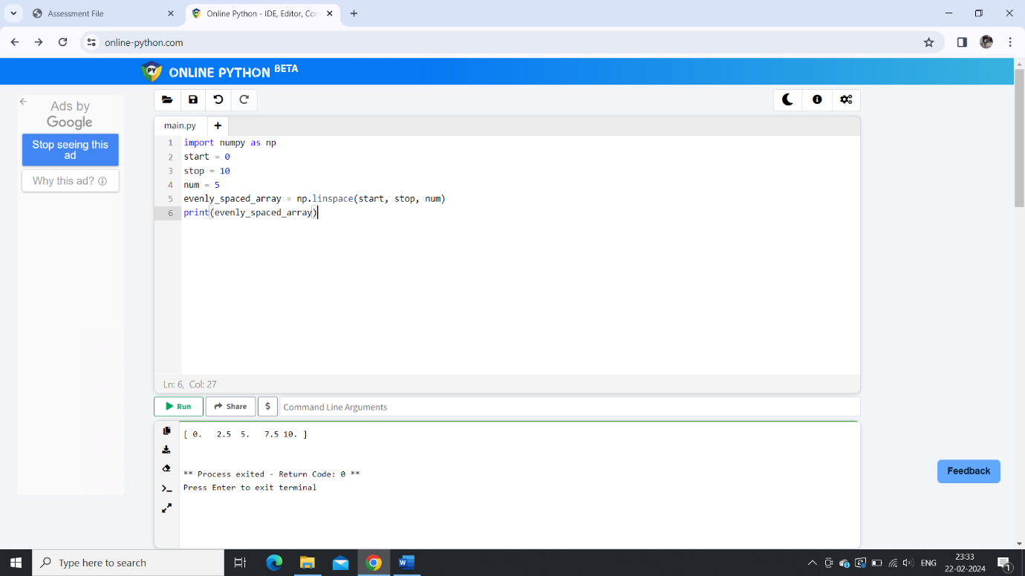

14 ans.

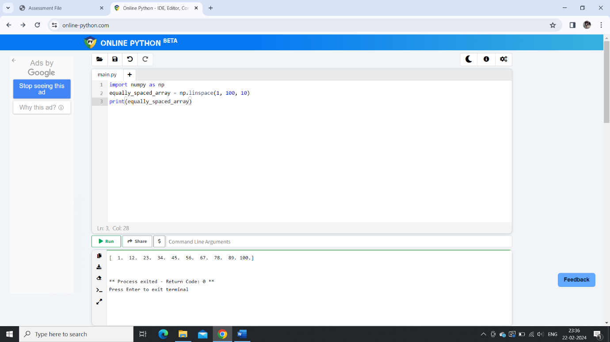

15 ans.

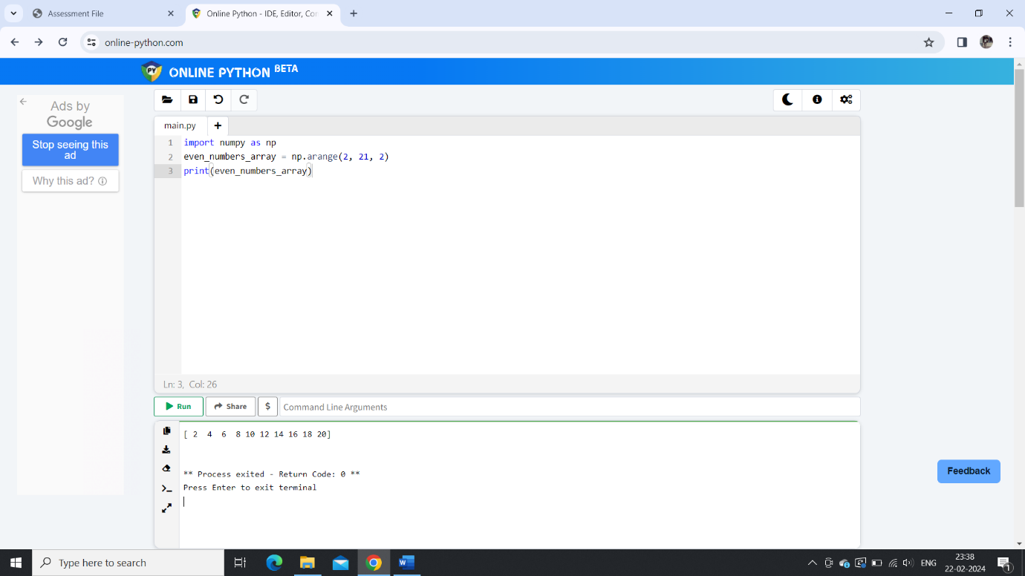

16 ans.

